

**111,oprtetary**

|  |  |  |  |  |  |
| --- | --- | --- | --- | --- | --- |
| Effective Date:  1 3 _ _N 2016 | **O PT.**Merck Sharp Dohme Pharma Tbk | | | Datasheet No:  C 1 7 u 7 | |
| Superseded No: QC-01-011.03 | Data Sheet  Check List Variable Database Empower for  Anal sis with HPLC and GC Method | | | Documen t No: QC-01-011.04 | |
| Prepared by: | | Reviewed by:  IO J'\J t'\ t b | Approved by: | |  |

|  |  |  |
| --- | --- | --- |
| Product Name/Purp ose | Oi fo S"tn'U> *0* ·11,,t."'--'-l,\ l · | |
| B atch No | b8PPAD02. ?t-- (t l\ll'<;.)·. 7P,DPAocy |  |
|  |  |

**SECTION 1:** Analist melakukan pengecekan ulang terhadap raw data yang dimasukkan ke dalam variable database Empower

c. B erat Sample/ Volum e Sample

Yes 0

Yes e5 Yes e,-

Yes (9"

**Yes** O

Yes @"

No Q No Q N o Q No Q No e

No Q

Keterangan:

/ -

I

a. B era t Standard

b. Standard Diluti on

d. Sampl e Dilution

e. AUW (Tablet Only)

f. Label Claim

g. Standard Potenc y

**Yes** 0'

No Q

h. Sample Set Pre Run

**Yes**

No 0

|  |  |  |  |  |  |  |  |  |
| --- | --- | --- | --- | --- | --- | --- | --- | --- |
| Perfonned by & Date | ( | l | R' | *A-* | p | *r* | l | *?* |
| **Verified** by & **Date** | k, ..., | I | *6'* | A | p | r- | \ | *·r* |

**SECTION 2:** Lab Supervisor melakukan pengecekan terhadap raw data yang dimasukkan Analist ke dalam variable database Emoower

**Yes** *(St* No Q

**Yes** G No Q

**Yes** g- No Q

**Yes** O No (9 **Yes** *(5* - No Q **Yes** 0 **NoQ**

**a. Berat Standard**

**Yes**

No Q

1. **Standard** Dilution
2. **Berat Sample/ Volume Sample**
3. **Sample** Dilution

**e. AUW (Tablet Only)**

f. **Label Claim**

g. **Standard** Potency

j **Review ed by** & **Dat e** c I I *9* A Ir I *r* I l '.t-- 1

|  |  |  |  |  |
| --- | --- | --- | --- | --- |
| **His** | **tory** | **:** |  |  |
|  | **1 .** |  | QC-01-011.00, Effective date: 29 Nov 2006 (New Edition) |
|  | 2. |  | QC-01-011.01, Effective date: 20 Nov 2008, LCR No.CR1108373D, Date of Issue: 19 Nov 2008 |
|  | 3. |  | QC-01-011.02, Effective Date: 30 Au,s1 2013 TR No.133973, Date of Issue: 22 May 2013 |
|  | **4.** |  | QC-01-011.03, Effective Date: **l j** J ' · |  |
|

f



PT. **Merck** Sharp Dohme Pharma Tbk

HPLC DATASHEET

Document No: QC-01-008 05

Approved by:

Effective Date:

1 J ., ltl 2016

Datasheet No:

C "'O 1 '". 0

Supers eded No: QC-01-008 .04

Prepared by:

r-:-1

Data Testing

**Proprietar y**



Reviewed by:

Test

&etoU!t.-l:vt .r-dl1.e- *· p,--ot_nv na l€*

HPLCID

I , *LC.* O'! *co* ICal ibra ti on Due Date I

cir.n y jProcedureDoc ;1 1C. JiO()q

Jnl,) l'i

0 7

F tr u ment Use Log Yes G

Column Name

'3CX,0 .9 WJIM lO u,.. CLV uP;(/1,')av-rc }c

I Column Use og Yes B-

Guard Column

·,

In jec tion Volume I LO U L .

Mobil Phase



- - -

o Expiry Date

--- -

No Reagent Name Lot N

-

3c.> Ar' t9

i Ac..etoni*\ri* 1i3033.0

*1.*

l·h. O

1 - - - - *N1r*

,_

-

*\l,'" J*

-

(KeratnanA) uton,tr,k • \-l-i.,-0 -; tooo '- *IDvo U,,*\

D ilu en ts

-

No

- - -

----

Reagent Name

I

-

~~-~~

Lot No

Exp iry Date

L o l _ J

\

l-\.1-0

N7t j 6D

I

31 Ju\ 19 <;40

I

*N1.l*

NI\-

*l-*

Mell.A*a*1.1*o* \

J <g4 l{oo*7*

..,,..

NA

tv7.\

(Ke t e r angan) e,J Ii

Page I of 2



**P ropr la la r-y**

|  |  |  |  |  |
| --- | --- | --- | --- | --- |
| Effective Date: | PT. Merck Sharp Dohme Pharma Tbk | | Datasheet No:  C C 2 0 | |
| Superseded No: QC-01-008.04 | HPLC DATASHEET |  | Document No: QC-01-008.05 |  |

Standard

|  |  |  |  |  |  |
| --- | --- | --- | --- | --- | --- |
| Standard Name | | Lot No | | Exp iry Date | Potency |
| t - t71*·pro* ' d.o., 2 | | L-ooy nu; *ODOI-/D)J* |  | *JI* Ail *llf* ,9 | *'J'). I* /4 |
| &edo - 'pro | | L-uo49{;eit171· *0001..vo2.* | *31* Jul t9 | 99-7 *½* |
|  | |  | |  |  |
|  | |  | |  |  |
|  |  |  | |  |  |
|  |

Sample

---

*.J* ·------

I**(Ketecangan) "I!**

[ **Refer to Weighing Record No** io Jo3rr , c.17olr6 .CtJoJS7. ('70361, *l17oJl ;* c1703£, For the printout

OJ

|  |  |
| --- | --- |
| **Sample Name** | **B atch No/ Contro l No** |
| Oi s- Oll-? t \..\.U,t,tl | G *BDPAoo-i.* v-- 5 re1:etl |
| Qip Ot11t t«-wl | 7 P,l)p.4 DOlf |
|  | ~~----~~ |
| **"**  - | **Ip.** |
|  | |

**System Suitability**

**Parameters Met Yes No**

- A-pr 1 7

------



**Hi sto ry:**

1. QC-01-008.00, Effective Date. 17 Jan 2005, initial release
2. QC-01-008.01, Effective Date: 09 Aug 2006, LCR No.CRQC0806085, Date of Issue: 08 Aug 2006

3 QC-01-008.02 , E:ffect,ve Date · 11 Feb 2008, LCR No.CR0208045D, Date of Issue: 05 Feb 2008

4. QC-01-008.03 , Effective Date: 20 Nov 2008, LCR No.CR1108372D, Date of Issue: 18 Nov 2008

5 QC-01-008.04 , Effective Date: 11 Jun 2013 TR No.133968, Date of Issue: 22 May 2013

6. QC-01-008.05, Effective Date: **1** .)

**.,., 6**

Page **2** of2





I **R e vi ewed by** & **Date**

1 1

9 A l p r l i l 1-I

**H is to ry :**

1. QC-01 -001 .00, Effect ive Date: 25 Juli 2003
2. QC-01-001.01, Effective Date: 18 Jan 2005, LCR No.01QC0105014, Date of Issue: 17 Jan 2005

3. QC-01-001.02, Effective Date: 11 Jun 2013, TR No.133963, Date of Issue: 22 May 2013

**4.** QC-01-001.03, Effective Date: 1 3 *JL;;:* "c...,"l'":

|  |  |  |  |  |
| --- | --- | --- | --- | --- |
| **Effective Date:**  1 3 JUN 2016 |  | | |  |
| **Supe rs ed ed No :**  **QC-0 1-001.02** | **WEIGHING RECORD** | | | **Document No:**  **QC-0 1-001.03** |
| **Prepared by:**  ?J "- | | **Reviewed by:**  C ""' ..- 101"4-··-'b | **Apprqved by:**  **/4** {.-:' (C ]Ul | |

|  |  |
| --- | --- |
| **Product Name/Pu se** | **Batch No** |
|  | .,Th!SVPADu2.. r9 rt *s*  I S- *yr* 1 -7 7GPP4cc..'1 |
| 18.04.2 17 10:37 18 .04.2 0 17 10:43 18.04.20 17 10:51  1e1T::.1Lrn 16MT0200 16M T0200  t1A E:AHAN Peta dipro 1 tlAMA BAHAN Beta d 1 pt o 2 NAMA BAHAN 8eclo dipro  LOT tflTCH LOT/BATCH LCITIBATCH  L-r•:148!::3263"-000HJ11 n 4° 3263-090H011 L-004960471-·00:)U:02  1 0 .0000 g 1 0.0000 g .1, 0.0000 g  0.0503 g 2 11. oc-01 9 ;_ 0 07 03 '3  7 · 0 .000 '3 3 e.0000 '3  3 0.0(100 '3 n 3  n 7-· n 3  X 0 . 016 77 '3 **X** 0.01670 **9** 0 .010E1 '3  ;:. 0.02893 9 0.01749  0 .02904 '3 9  *:;*.rel 173 . 17 .•..., :;.rel 173 .23 *=·=* 5.rel 173.17 %  Min 0.0000 '3 1in 0 .0000 '3 1in 0.0000 g  Ma:<: 0.0503 '3 "lax 0.0501 '3 ·1ax 0.0-.;03 g  Dif f. 0.0503 •3 D1ff. 0.0501 g Diff. 0.0 03 g  51.m, 0.0503 '3 Su 0.050 1 '3 0.0303 3  .3ignatu  I e • • • a • ., ., • "" • • "" • • "" • ti • e • S  • • • • • • • • • • • • • • • • • • • • • II | |



*"1 t•* n: C" ,

|  |  |  |  |  |  |  |  |  |  |  |
| --- | --- | --- | --- | --- | --- | --- | --- | --- | --- | --- |
| Effective | Date:  1 3 JUN | | 2a10 | **.Z.PT.**Merck Sharp Dohme Pharma Tbk | | | | | Datasheet No:  . 6 | . |
| Supen eded No:  **QC-01-001.02** | | |  | WEIGHING RECORD | | | | | Document No:  **QC-01-001.03** | |
| **Prepared by:**  J -,·, ...,, | | """ Hs |  |  | **Reviewed by:**  c | IO J""'' | \I:, | **Apprqt1ed by:**  *I :..* I C ] U11 .  l'. | | |

|  |  |  |  |  |
| --- | --- | --- | --- | --- |
| **Product Name/Purpose** | | **Batch No** | | |
| 0·1 prv.Wl1.R_ | 0 rj 1t.\M.k- t.t.t | f- Q.D PA *oo*  7GD PA-oo'I | i) | reberi-- |

18.04.2£417

16W

<:it1A B

'11-1 BAHA

:,1proso.-e 1 d: *e*

-T t1 TCH.

1:3. (1 4 .:2017

1i:; -:-1:12013

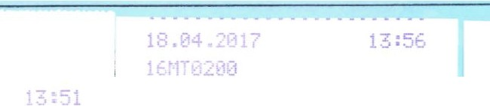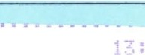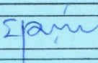

'A BAHAN

ointr ert



_

[ 1proso P :>irtr,ent

- H 1

BDP.;002 :t 3 top 1 2

1 0 .f100i:i "3

2 2.0134 "3

61:i[

Cl top 2

0 9

*L* .011.£. 3 2

*.!.* ..,

1.005i:-0 g

BDP.;(102 st *9* tlld 1

0.0

2.0134 g

-

,_

1 j o '3

...

l<

;-

*=-.*1·*e*1

1in

Ma:,-;

D1ff.

2

1.00670 3

0.0000 g

2.0134 g

2 .(113..t 9

s

.s.rel

Min

M-:1X

(:tiff.

Sum

------ -

- .t· .l

------

0.0000 '3 1t

2.0112 '3

.

2.0112 "3 1-t=f•

2.0112 '3

------

------

0.0003 '3

2.0134 '3

2 .0134 '3

2.0134 '3

;um

2.0134 g

Sign<:.: : t i _

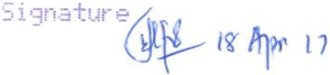l5' *Ar* 17

**Reviewed by** & **Date** *:)* **A** *r* r

**History :**

1. QC-01-001.00, Effective Date: 25 Juli 2003
2. QC-01-001.01, Effective Date: 18 Jan 2005, LCR No.01QC0105014, Date of Issue: 17 Jan 2005
3. QC-01-001.02, Effective Date: 11 Jun 2013, TR No.133963, Date of Issue: 22 May 2013

**4 .** QC-01-001.03, Effective Date: 1 3 *Jl;\l* ,..,,,.

L V *.J*

I

I [):R;

I G{.I f•--- 1

'"I' c '","

,w '

n -:- - - - - - - - --.

|  |  |  |  |  |  |  |  |
| --- | --- | --- | --- | --- | --- | --- | --- |
| Effec tive Date:  1 3 JUN 2 16 | .._,.,PT. Merck Sharp Dohme Pharma Tbk | | | | | Dataaheet No:  7 | |
| **Supel"leded No: QC-01-001.02** | **WEIGHING RECORD** | | | | | **Document No: QC-01-001.03** | |
| **Prepared by:**  T; '"' | | **Reviewed by:**,  c | - | I O jV '"' \b | **Apprcwed by:**  ( *1: \ ... IG* Jun | | (- |

|  |  |  |  |  |
| --- | --- | --- | --- | --- |
| **Product Name/Pu oae** | **Batch No** | | | |
|  | *b* p,t> PA *o o* 2...  78 D p4004 | *9* | r | r |

!6MT02 10

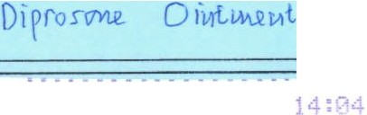

18.IJ·l.2017



- AMA BAHAN

Dip1·osc1 e oir,tr,er+

LOT1P. -H

BDPG 2 11d 2

18.04.2017 

!6t1T0200

NAMA 8.'.;HA•

[)1pros,:me 0 1r,tme1--t:

... T

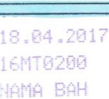D1prosone oi'ltqert

'["IT(H

6BDPA0 }2 :.t 9 Bi:rn 2

1 HJ01 ·3

.0650 g

!..OT/BATCH

68DP 002 .;;t '3 Btn 1

1 0. 000 9

2 .0HJ9 '3

*=-* .rel

1n

!: ff.

:

2 1

 ....

.,

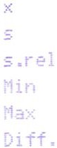n

3.(f 03 g

.... - J 9 2.0:)50 g

2.0050 g

0.0c00 9

.....0071 g

2

1 . 33rc;

0 0800 "3

2.0.:,71 ·=i

•')

*Y.*

s .rel Min M.;ix D1ff.

*2*

1 .00545 '3

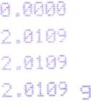

j

9

9

::- - -+ :.um





: .e ,·

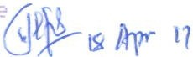., .

*,* .... /

I **Reviewed by** & **Date**

**History:**

1. QC-01-001.00. Effective Date: 25 Juli 2003
2. QC-01- 001.01, Effective Date: 18 Jan 2005, LCR No.01QC0 105014,Date of Issue: 17 Jan 2005
3. QC-01-001.02, Effective Da te: 11 Jun 2013, TR No.133963, Date of Issue: 22 May 2013

1 3 JL. ,..,,,.

1. QC-01-001.03, Effective Date:

*t. v ....J*



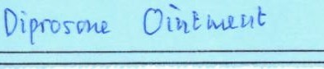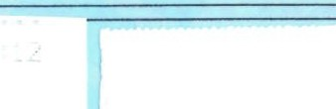



I **Reviewed by** & **Date**

**History :**

1. QC-01-001.00, Effective Date: 25 Juli 2003
2. QC-01 -001.0 1, Effective Date: 18 Jan 2005, LCR No.01QC0105014,Date of Issue: 17 Jan 2005

**4.** QC-01-001.03, Effective Date: 1 3 JU ,,.,,,.

3. QC-01-001.0 2, Effective Date: 11 Jun 2013, TR No.133963, Date of Issue: 22 May 2013

*L .* 'J

1yttf"'tJ

|  |  |  |  |  |  |  |  |  |
| --- | --- | --- | --- | --- | --- | --- | --- | --- |
| **Effective Date:**  **1 3** JUN 2a16 | |  | | | | | | |
|  | | | |  | | |
| **Superseded No:**  **QC-0 1-001.02** | | **WEIGHING RECORD** | | | | **Document No:**  **QC-01-001.03** | | |
| **Prepared by:**  J.,f}.':.._:{. "; | r ""' '" |  | **Reviewed by:** .,  c | -..- I OJV '" 'b | **Apprcwed by:**  , </c.t. *"1-tf :.*• - | | 1  \0 | ,  W"I ...., |

|  |  |
| --- | --- |
| **Product Name/Pu ose** | **Batch No** |
|  | *6Bon,4oe,2.*  7 eDPA *ool-1* |

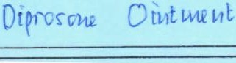





|  |  |  |  |
| --- | --- | --- | --- |
| **Effective Date:**  1 3 JUN 2016 |  | | |
| **Supeneded No: QC-01-001.02** | **WEIGHING RECORD Document No: QC-0 1-001 .03** | | |
| J ,..,. -,(:  **Prepared by:** | | **Reviewed by:**  c I O JV '" 'b | **Apprcwed by:**  *I* </,'c.v '-*/*t.*:*-_*.-*• \o '] u•1I |

|  |  |
| --- | --- |
| **Product Name/Pu oae** | **Batch No** |
|  | *&Bl)p,4coz_* ½ '.l  7 *BOPAooLf* |

*wr* pi-i11t *,.-,tpr* ,7

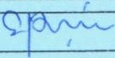

11 AF *"1*

I **Reviewed by** & **Date** l I A l r l r l 1 lr l

**History:**

1. QC-01-001.00, Effective Date: 25 Juli 2003
2. QC-01-001 .01, Effective Date: 18 Jan 2005, LCR No.01QC0105014, Date of Issue: 17 Jan 2005
3. QC-01-001.02, Effective Date: 11 Jun 2013, TR No.133963, Date of Issue: 22 **May** 2013

**4.** QC-01-001.03, Effective Date: 1 3 JU,'l : :5



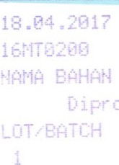

:40

·

X

1 tment

-w1·PA0[14

J .0000 •3

2 .0144 "3

2

1.00,20 3

*=-* .t·el in 1ax

·if-f.

51.m,

0.0000 g

2.0144 '3

2.0144 g

2.0144 g

Sigr;j.



**.4.............11**

Effective Date:

1 3 JUN 2016

**Superseded No: QC-01-001.02**

**.Z.PT.**Merck Sharp Dohme Pharma Tbk

**WEIGHING RECORD**

I""!'' ' ct ,... ,

I

**Datasheet No:**

C

**Document No: QC-01-001.03**

3

**Prepared by:**

,L.., --.- "

.,... ;

- '"'

**Reviewed by:**

c

**Apprq.ved by:**

--

to "'"'

*t*

*f* ., '

. "- tc ') w

1:

|  |  |
| --- | --- |
| **Product Name/Purpose**  Y)) Svi-U C 1}t tw.-11t. | **Batch No** |
| l P., t)-pADo *"L* \/}· *'.)*  *7 P,DPA ooy* |

I **Reviewed by** & **Date**

**Hist ory :**

1. QC-01-001.00, Effective Date: 25 Juli 2003
2. QC-01-001.01, Effective Date: 18 Jan 2005, LCR No.01QC0105014, Date of Issue: 17 Jan 2005

I I I 9 I *1t-* I *r* If ,I 1,.

3. QC-01-001.0 2, Effective D ate: 11 Jun 2013, TR No.133963, Date of Issue: 22 May 2013

4. QC-01-001.03, EffectiveD ate: 1 3 *JU'l* """'t::

*(.*

**[§jjj**,**f***,1(1111J*

**software** Systemsuitability

***PT. Schering Plough Indonesia Tbk.***

I

***Quality Control* T**

***Analytical Report*** 15

Sample Name: Bet-dip std-1 Sample Type: Standard

Vial: 25

Injection #: 1

Injection Volume: 10.00 ul Run lime: 22.0 Minutes

Acquired By: aalfiani

Sample Set Name: 6BDPA002_St9 inv Acq. Method Set: BDPA_BetDip Met Set Processing Method BDPA_ProcMetLC02 Channel Name: 2487Channe l 1

Proc. Chnl. Descr.: 2487Channe l 1

Date Acquired: Tuesday, April 18, 2017 1:26:42 Prv1 wrr

Date Processed: Wednesday, April 19, 2017 7:33:27 AM wrr

i •• **t**

l

**Auto-Scaled Chromatogram**

r--

-

-

-

-

-

-----=....,_---===---.....-

C17

0120

I

J

::::,

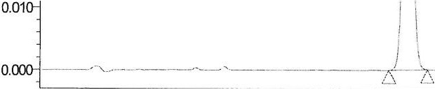

llC - 01- 00 .

*l*

µQ(,i)

la.

-

I_ >r_ l 7 -

i6

16

ru

0.020

*I«>*

0/'1

II I,

*I* \

*l i !* L5\ \-. - - - - -

<(

I I I I I I I 1 I I I I t 1 I I I I I I ' I t I I I I I I I I I I I I I I I I ' ' I

2.00 4.00 6.00 8.00 10.00 12.00 14.00 16.00 18.00 20.00 22.00

Minutes

**Peak Results**

|  |  |  |  |  |  |  |  |  |  |  |
| --- | --- | --- | --- | --- | --- | --- | --- | --- | --- | --- |
|  | Name | RT | Area | Height | Annnt | USP Resoh.tion | USP Tailing | USP Plate COUll | KPrirre | |
| 1 | Beta--diJYO | 9.080 | 875982 | 52844 | 50.300 |  | 1.0 | 6834.0 |  | 8.1 |
| : 2 | Beclo-diJYO | 11 .18€ | 962159 | 47428 | 1.000 | 4.2 | 1.0 | 6908.4 | 10.2 | |

'

Reported by User: Alfiani, Alfiani (aalfiani) Report Method: Sy stemSu itability

Report Method ID: 1 07 4

Page: 1 of 1

Project Name: Pandaan\2017_Q1\BDPA Bet.Dip_TemplatE

Date Printed : Wednesd ay , April 19, 201i 9:21:58 AM Asia/Jakartc

***r/jJ*** Sc ring )llg

Report Method: Std Samp

**Quality Control**

### Analytical Report

Report ed by: Alfiani, Alfian i (aalfia Project: Pandaan \2017 Q1\BISys: 13 LC0300

Sample Name: 6BDPA002 st 9 middle 2, Sample Type : Unknow n, Standard

Vial: 26, 28, 29, 31, 25, 32, 27, 30

Injection #: 1, 2, 3 Injection V olume: 10.00 ul

Run Time: 22.0, 16.0 Minutes Sample Set Name: 6BDPA002 _St9 inv

Acquired By: aalfiani

Date Ac quired: Tuesday, April 18, 2017 1:26:42 Ac q. Method Set: BDPA_BetDip Met Set

Date Proces sed: Wednesday, April 19, 2017

Processing Method: BDPA ProcMetLC02 Processed by aalf iani/GBL_Chemist

Sample Set Start DatE Tuesday, April 18, 2017 1:25:4 2

::i

<{

### Standards

*z.*

***C 170 1 2 D***

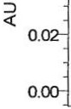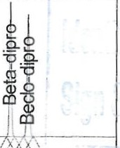

0.04

I

' l I I

**llC-01-008.05**



10.00 20.00

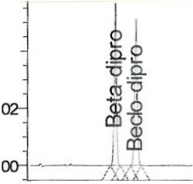

0.04

0.

0.

I ' I I I ' I I I I I

Mirues

Bet-dip std-1;

**Mirues**

Bet-dip std-1 ;

10.00

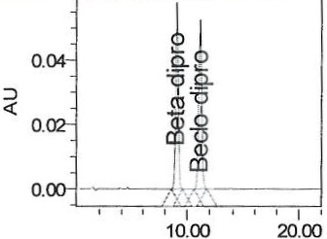**Minutes**

Bet -dip s td- 1;

20.00

Tuesday, April 18,

2017 1:26:4 2 PI\/I

W IT; lnj Id 1890

Tuesday, April 18,

2017 1:49:36 **PI\/I**

WIT; lnj Id 1893

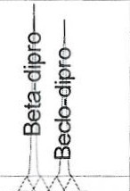

I '

' I

0.

0.

::i

<{

0.04

0.

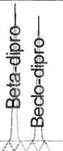

' I

Tuesday, April 18,

2017 2:12:31 PI\/I

W IT; lnj Id 1895

2.00



0.04

0.

- ---- *n-*

it0

*b*a. I

(1) *()*

ail (1)

I

0.

... *\I :* \

I

**Mirues**

16.00

0.

2 . 00

**Mirues**

16.00

0.

2.00

Mirues

16.00

0.04

0.

Bet-dip std- 2; Tuesday, A pril 18, 2017 3:20:15 **PI\/I**

W IT; lnj Id 19 21

k I

pQ.

'a9. .2



::i

<{

Bet-dip s td-2; Tuesday, April 18,

2017 3:37:27 PI\/I

W IT; lnj Id 192 3

Bet-dip s td-2; Tuesday, April 18, 2017 3:54:22 PM

WIT; lnj Id 1926

.om+-I -• I -JI , I

2 . 00 16.00

**Mirues**

Bet-dip s td- 2; Tuesday , April 18, 2017 3:20:15 **PI\/I**

WIT; lnj Id 1921

2 . 00 16 . 00

**Mirues**



0.04

J

! I

.Q- e

"O .Q.

0.

0.

I I I I I I I I

,........,.---,-_,1:r_

..

Bet-dip std-2; Tuesday, April 18, 2017 3:37:27 **PI\/I**

W IT; lnj Id 1923

Bet-dip std -2; Tuesday , April 18, 2017 3:54:22 PI\/I

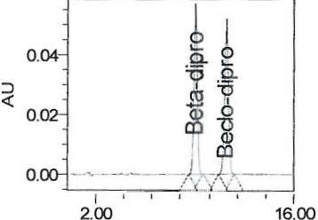

Mirues

W IT; lnj Id 1926

Sample Set: 6BDPA00 2_St9 inv Printed 9:22:33 AM ,Wednesday, A Page: 1 of 6

***rip*** Scl , ing 1 !o

Report Method: Std Samp

**Quality Control**

### Analytical Report

Reported by: Alfiani, Alfiani (aalfia Project: Pandaan\2017 Q1\BISys: 13 LC0300

::,

*<(*

::,

*<(*

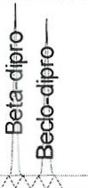

0.04

0.

0.

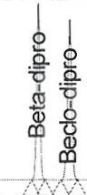

0.04

0.

0.

I

I I

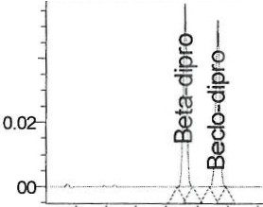

0.04

0.

I ' ,

I

2.00

Minues

I

16.00

2 .00

Minues

16.00

2.00

**Milll1es**

16.00

Bet-dip std-2; Tuesday, April 18,

2017 4:46:19 **PM**

WIT; lnj Id 1949

Bet-dip std-2; Tuesday, April 18,

2017 5:38:00 **PM**

WIT; lnj Id 1981

**Name : Beclo-dipro**

Bet-dip std-2; Tuesday, April 18,

2017 6:29:35 PM

WIT; lnj Id 1990

**Cal Curve Id: 2065**

?

**c110120**

|  |  |  |  |  |  |  |  |  |  |  |
| --- | --- | --- | --- | --- | --- | --- | --- | --- | --- | --- |
|  | SM"ple Narre | Nine | Vial | hi | RT  {rrin) | Area | Amlunt | Area  {µV'sec) | ResponseFactor | Manual |
| 1 | Bet-dp std-1 | Beclo-dipro | 25 | 1 | 11.18€ | 962159 | 1.000 | 962159 | 962158.56289 | No |
| 2 | Bet-dip std-1 | Beclo-dipro | 25 | 2 | 11.16S | 982150 | 1.000 | 982150 | 982150.37084 | No |
| 3 | Bet-d p std-1 | Beclo-dipro | 25 | 3 | 11.167 | 981822 | 1.000 | 981822 | 981821.57993 | No |
| 4 | Bet-dip std-2 | Beclo-dipro | 26 | 1 | 11.11e | 98211E | 1.000 | 98211E | 982115.3979: | No |
| 5 | Bet-cip std-2 | Beelo-dipro | 26 | 1 | 11.11e | 98211E | 1.000 | 98211E | 982115.3979: | No |
| 6 | Bet-dip std-2 | Beclo-cipro | 26 | 2 | 11.17S | 973171 | 1.000 | 973171 | 973171.14986 | No |
| 7 | Bet-dip std-2 | Becio-dipro | 26 | 2 | 11.175 | 973171 | 1.000 | 973171 | 973171.14986 | No |
| 8 | Bet-dip stcl-2 | Beelo-dipro | 26 | 3 | 11.181 | 972500 | 1.000 | 972500 | 972500.20089 | No |
| 9 | Bet-dpstcl-2 | Beelo-dipro | 26 | 3 | 11.181 | 972500 | 1.000 | 972500 | 972500.20089 | No |
| 10 | Bet-dp stcl-2 | Beelo-dipro | 26 | 1 | 11.21e | 975301 | 1.000 | 975301 | 975301.28351 | No |
| 11 | Bet-dp stcl-2 | Beclo-dipro | 26 | 1 | 11.257 | 982848 | 1.000 | 982848 | 982847.54637 | No |
| 12 | Bet-dip stcl-2 | Beclo-dipro | 26 | 1 | 11.283 | 984721 | 1.000 | 984721 | 984721.03671 | No |
| Mean |  |  |  |  | 11.2 | 977048 |  |  |  |  |
| % RSD |  |  |  |  | 0.3 | 0.7 |  |  |  |  |

**uc-tn-ooa. os**



|  |  |  |  |  |  |  |  |  |  |  |  |  |
| --- | --- | --- | --- | --- | --- | --- | --- | --- | --- | --- | --- | --- |
|  | SM"ple Narre | Nine | Vial | lrj | RT  (rrin) | Area (µV' sec) | ResponseFactor | Stdl/lA (rrg) | Labet_Strength | Std  Potency | Std  Dilution | lrj Id |
| 1 | Bet-dip std-1 | Beelo-dipro | 25 | 1 | 11.186 | 962159 | 962158.56289 | 1.000 |  |  |  | 1890 |
| 2 | Bet-d p std-1 | Beclo-dpro | 25 | 2 | 11.169 | 982150 | 982150.37084 | 1.000 |  |  |  | 1893 |
| 3 | Bet-dip std-1 | Beclo-dpro | 25 | 3 | 11.167 | 981822 | 981821.57993 | 1.000 |  |  |  | 1895 |
| 4 | Bet-dip std-2 | Beclo-dipro | 26 | 1 | 11.178 | 98211! | 982115.3979: | 1.000 |  |  |  | 1921 |
| 5 | Bet-dip std-2 | Beclo-cipro | 26 | 2 | 11.179 | 973171 | 973171.14986 | 1.000 |  |  |  | 1923 |
| 6 | Bet-dip std-2 | Beclo-dipro | 26 | 3 | 11.181 | 972500 | 972500.20089 | 1.000 |  |  |  | 1926 |
| Mean |  |  |  |  | 11.2 | 975653 | 975652.87805 |  |  |  |  |  |
| %RSD |  |  |  |  | 0.1 | 0.82026 | 0.82026 |  |  |  |  |  |

**Cal Curve Id: 2074**

|  |  |  |  |  |  |  |  |  |  |  |  |  |
| --- | --- | --- | --- | --- | --- | --- | --- | --- | --- | --- | --- | --- |
|  | SM"ple Narre | Natre | Vial | lrj | RT  (rrin) | Area (µV'sec) | ResponseFactor | *Std I/IA*  (rrg) | Label_Strength | *Std*  Potency | Std  Dilution | lrj Id |
| 1 | Bet-dip std-2 | Beclo-dpro | 26 | 1 | 11.178 | 98211! | 982115.3979: | 1.000 |  |  |  | 1921 |
| 2 | Bet-dp std-2 | Beclo-dipro | 26 | 2 | 11.179 | 973171 | 973171.14986 | 1.000 |  |  |  | 1923 |

Sample Set: 6BDPA002_St9 inv Printed 9:22:33 AM 1Wednesday, A Page: 2 of6



Report Method: Std Samp

## Quality Control

#### Analytical Report

Reported by: Alfiani, Alfiani (aalfia Project: Pandaan\2017_Q1\8ISys: 13_LC0300

**Cal Cur ve Id: 2074**

|  |  |  |  |  |  |  |  |  |  |  |  |  |
| --- | --- | --- | --- | --- | --- | --- | --- | --- | --- | --- | --- | --- |
|  | **Sen-pie**  **Narre** | **Ncrre** | **Vial** | Iii | RT  (nin) | ***kea***  (µV'sec) | **ResponseFactor** | **StdW.**  (rrg) | Label_Strength | Std Potency | Std Dilution | Iii Id |
| 3 | Bet-cip std-2 | **Beclo-dipro** | 26 | 3 | 11.181 | 972500 | 972500.20089 | **1.000** |  |  |  | 1926 |
| **4** | Bet-cip std-2 | Beclo-dipro | 26 | 1 | 11.218 | 975301 | 975301.28351 | 1.000 |  |  |  | 1949 |
| 5 | Bet-dp std-2 | **Beclo-dipro** | 26 | 1 | 11.257 | **982848** | 962847.54637 | **1.000** |  |  |  | 1981 |
| 6 | Bet-dip std-2 | Beclo-dipro | 26 | **1** | 11.283 | 984721 | 984721.03671 | 1.000 |  |  |  | 1990 |
| Mean |  |  |  |  | 11.2 | 978443 | 978442.77021 |  |  |  |  |  |
| %RSD |  |  |  |  | 0.4 | 0.55091 | 0.55091 |  |  |  |  |  |

**Ca l Cu r ve Id: 2064**

|  |  |  |  |  |  |  |  |  |  |  |  |  |
| --- | --- | --- | --- | --- | --- | --- | --- | --- | --- | --- | --- | --- |
|  | Sen-pie  Narre | Narre | Vial | Iii | RT  (nin) | *kea*  (µV'sec) | ResponseFactcr | StdW.  (rrg) | Label_Streng th | Std Potency | Std Dilution | Iii Id |
| 1 | Bet-cip st d-1 | Beta-dipro | 25 | 1 | 9.080 | 875982 | 0.01810 | 50.300 | 0.64000 | 0.99300 | 400.00000 | 1800 |
| 2 | Bet-cip std-1 | Beta-dipro | 25 | *2* | 9.070 | 894512 | 0.01811 | 50.300 | 0.64000 | 0.99300 | 400.00000 | 1893 |
| 3 | Bet-dip std-1 | Beta-dipro | 25 | 3 | 9.065 | 893521 | 0.01809 | 50.300 | 0.64000 | 0.99300 | 400.00000 | 1895 |
| 4 | Bet-cip std-2 | Beta-dipro | 26 | 1 | 9.075 | 889691 | 0.01808 | 50.100 | 0.64000 | 0.99300 | 400 .00000 | 1921 |
| 5 | Bet-cip std-2 | Beta-dipro | 26 | 2 | 9.076 | 882612 | 0.01810 | 50.100 | 0.64000 | 0.99300 | 400 .00000 | 1923 |
| 6 | Bet-dip std-2 | Beta-dipro | 26 | 3 | *9.on* | 882197 | 0.01811 | 50.100 | 0.64000 | 0.99300 | 400 .00000 | 1926 |
| Mean |  |  |  |  | 9.1 | 886419 | 0.01810 |  |  |  |  |  |
| %RSD |  |  |  |  | 0.1 | 0.82576 | 0.05357 |  |  |  |  |  |

**Ca l Cur ve Id: 2073**

|  |  |  |  |  |  |  |  |  |  |  |  |  |
| --- | --- | --- | --- | --- | --- | --- | --- | --- | --- | --- | --- | --- |
|  | Sen-pie  Narre | Narre | Vial | lrf | RT  (nin) | *kea*  (µV'sec) | ResponseFactor | StdW.  (rrg) | Label_Strength | Std Potency | Std Dilution | Iii Id |
| 1 | Bet-dip std-2 | Beta-dipro | 26 | 1 | 9.075 | 889691 | 0.01808 | 50.100 | 0.64000 | 0.99300 | 400 .00000 | 1921 |
| 2 | Bet-dip std-2 | Beta-dipro | 26 | 2 | 9.076 | 882612 | 0.01810 | 50.100 | 0.64000 | 0.99300 | 400.00000 | 1923 |
| 3 | Bet-dip std-2 | Beta-dipro | 26 | 3 | *9.on* | 882197 | 0.01811 | 50.100 | 0.64000 | 0.99300 | 400.00000 | 1926 |
| 4 | Bet-dip std-2 | Beta-dipro | 26 | **1** | 9.104 | 884226 | 0.01810 | 50.100 | 0.64000 | 0.99300 | 400.00000 | 1949 |
| 5 | Bet-dip std-2 | Beta-dipro | 26 | **1** | 9.133 | 890540 | 0.01809 | 50.100 | 0.64000 | 0.99300 | 400.00000 | 1981 |
| 6 | Bet-op std-2 | Beta-dipro | 26 | 1 | 9.153 | 892927 | 0.01810 | 50.100 | 0.64000 | 0.99300 | 400.00000 | 1990 |
| Mean |  |  |  |  | 9.1 | 887032 | 0.01810 |  |  |  |  |  |
| %RSD |  |  |  |  | 0.4 | 0.51642 | 0.05433, |  |  |  |  |  |

y

**C170120**

**llC-01-008.05**



Sample Set: 6BDPA002_St9 inv Printed 9:22:33 AM ,Wednesday, A Page: 3 of 6

**rip** Sci

Report Method: Std Samp

Quality Control

#### Analytical Report

Reported by: Alfiani, Alfiani (aalfia Project: Pandaan\2017 O1\BISys: 13 LC0300

I **Samples**

:) :)



0 .04

I ' '

el

i

'9

a.

0

I

'o

"a".

6

*r* ·*.*'*0.;tt:.z*I *s-*

I

-0

I

<( <(

0.04

::,



I

- I

I i

-a e

I C)_

I &l

I 13

I

-- --

- J *-l- ---* -

*l : \ L::,.*

.Q. *9*

eI

JJ

.!ll "C

**,Q.**

,,

*' l \ C:.*

I I •

<(

0.

5.00 10.00 15.00

Mirues

0.

5.00 10.00 15.00



0.04

0 .

0.

*/*

I I

Mirues

5 .00 10 .00

Mirues

15.00

::,

<(

0 . 04

0 .

Tuesday, Ap ril 18, 2017 4:11:50 **PM** W IT;

6BDPA002 st 9 top 1; lnj 1;

lnj Id 1943

::,

<(

0 . 04

0 .

Tuesday, April 18, 2017

4:29:02 PM WIT;

6BDPA002 st 9 top 2; lnj 1;

lnj Id 1946

Tuesday, April 18, 2017

5:03:31 PM wrr;

6BDPA002 st 9 middle 1; lnj 1; lnj Id 1952

0.00

I

i

-

.9-

-0

*b*

.Q.

....

& "C

-0

&

- --

-- ·-Jl-L!:i --

I

I ' ' I ' ' ' I '

5 . 00 00

00 10 . 15 .

**Minu:es**

Tuesday, A pr il 18, 2017 5:20:44 PM W IT;

6BDPA002 s t 9 middle 2; lnj 1; lnj Id 1961

0 .

5.00 10.00 15.00

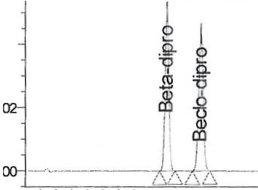

I I I I I ' ' I ' I I ' t ' I I

**Mirues**

Tuesday, April 18, 2017

5:55:11 PM WIT;

6BDPA002 st 9 bottom 1;

lnj 1; lnj Id 1984

5.00 10.00 15.00

**Mirues**

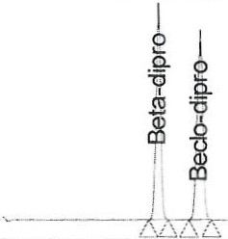

0.04

I I I 1 I I I I I I t I t I j I

Tuesday, April 18, 2017

6:12:21 **PM WIT;**

6BDPA002 st 9 bottom 2;

lnj 1; lnj Id 1987

**Sam pie Name: 6BDPA002 st 9 bottom 1**

|  |  |  |  |  |  |  |  |  |
| --- | --- | --- | --- | --- | --- | --- | --- | --- |
|  | **Na-re** | Vial | l rj | RT | Nea | Iii Id | PeakTwe | **Min.Jal** |
| 1 | Beclo-dipro | 31 | 1 | 11.27( | 891457.1 | 1984 | ! Std | No |
| Mean |  |  |  | 11.27( | 89145 7 |  |  |  |
| % RSD |  |  |  |  |  |  |  |  |

**Sam pie Name: 6BDPA002 st 9 bottom 2**

|  |  |  |  |  |  |  |  |  |
| --- | --- | --- | --- | --- | --- | --- | --- | --- |
|  | Na-re | Vial | lrj | RT | Area | lri Id | P eakTwe | **Ma'll.181** |
| 1 | Becl o-dipro | 32 | 1 | 11.27( | 921547.7 | 1987 | Int Std | No |
| Mean |  |  |  | 11.27( | 921548 |  |  |  |
| %RSD |  |  |  |  |  |  |  |  |

Sam p ie Name: 6BDPA002 st 9 middle 1

*s­*

C170120 nc-01-000.05

lq A-pf' *17*

|  |  |  |  |  |  |  |  |  |
| --- | --- | --- | --- | --- | --- | --- | --- | --- |
|  | Na-re | Vial | lrj | RT | Nea | lnj Id | PeakT)Pe | Minial |
| 1 | Becl o-dipro | 29 | 1 | 11.241 | 891158.C | 1952 | Int Std | No |
| Mean |  |  |  | 11.241 | 8911 58 |  |  |  |
| % RSO |  |  |  |  |  |  |  |  |

Sample Set: 6BDPA002_St9 inv Printed 9:22:33 AM 1Wednes day, A Page: 4 of 6



Report Method: Std Samp

## Quality Control

#### Analytical Report

Repo r ted by: A lfiani, Alfiani (aalfia Projec t: Pand aan\2017 Q1\8ISys: 1 3 LC0300

**Sample Name: 6BDPA002 st 9 middle 2**

|  |  |  |  |  |  |  |  |  |
| --- | --- | --- | --- | --- | --- | --- | --- | --- |
|  | **Ncrre** | Vial | lri | RT | P.i-ea | lri Id | PeakTwe | **Ma'lUai** |
| 1 | Beelo-dipro | 30 | 1 | 11.231: | 910969.5 | 1961 | Int Std | No |
| **Mean** |  |  |  | **11.231:** | 910970 |  |  |  |
| %RSD |  |  |  |  |  |  |  |  |

**Sample Name: 6BDPA002 st 9 top 1**



**Sam pie Name: 6BDPA002 s t 9 top 2**

|  |  |  |  |  |  |  |  |  |
| --- | --- | --- | --- | --- | --- | --- | --- | --- |
|  | Ncrre | Vial | lri | RT | *Area* | lri Id | PeakTwe | Maroal |
| 1 | Beclo-dipro | 27 | 1 | 11.174 | 904964.6 | 1943 | Int Std | No |
| M ean |  |  |  | 11.17< | 904965 |  |  |  |
| %RSO |  |  |  |  |  |  |  |  |

|  |  |  |  |  |  |  |  |  |
| --- | --- | --- | --- | --- | --- | --- | --- | --- |
|  | **Ncrre** | Vial | lnj | RT | *Area* | lri Id | PeakTwe | Manual |
| 1 | Beelo-dipro | 28 | 1 | 11.181 | 915654.8 | 1946 | Int Std | No |
| Mean |  |  |  | 11.181 | 915655 |  |  |  |
| %RSD |  |  |  |  |  |  |  |  |

**Sam pie Name: 6BDPA002 st 9 top 1**

b

## cno120

**o.c-01-ooa.os**



|  |  |  |  |  |  |  |  |  |  |  |
| --- | --- | --- | --- | --- | --- | --- | --- | --- | --- | --- |
|  | **Sa-rpleNare** | Narre | **Vial** | lrj | RT | *Nea*  (µV"sec) | ResponseFactor | **Amx.rt** | **Sa-rpl**eV\eight  {g) | Dilution |
| 1 | 68DPA002 st 9 top1 | Beclo-dipro | 27 | 1 | 11.17< | 904965 | 904964.56879 | 1.00000 | 2.0134 | 10.0000 |
| Mean |  |  |  |  | 11.17< |  |  | 1.00000 |  |  |
| % R SD |  |  |  |  |  |  |  |  |  |  |

**Sam pie Nam e : 6BDPA00 2 st 9 top 2**

|  |  |  |  |  |  |  |  |  |  |  |
| --- | --- | --- | --- | --- | --- | --- | --- | --- | --- | --- |
|  | SarrpleNarre | Narre | Vial | lrj | RT | *Nea*  {µV"sec) | ResponseFactor | Arroult | SarrpeV\eight  {g) | Dilution |
| 1 | 68DPA002 st 9 top 2 | Bec l o-dipro | 28 | 1 | 11.181 | 915655 | 915654.82835 | 1.00000 | 2.011:; | 10.0000 |
| Mean |  |  |  |  | 11.181 |  |  | 1.00000 |  |  |
| %RSD |  |  |  |  |  |  |  |  |  |  |

**Sample Name: 6BDPA002 st 9 middle 1**

|  |  |  |  |  |  |  |  |  |  |  |
| --- | --- | --- | --- | --- | --- | --- | --- | --- | --- | --- |
|  | SarrpleNare | Nare | Vial | lrj | RT | *Area*  {µV"sec) | ResponseFactcr | ArrOlrt | Sa-rpleV\eig ht  {g) | Dilliion |
| 1 | 680PA002 st 9 niddle 1 | Beclo-dipro | 29 | 1 | 11.241 | 89115€ | 8911 57.9927i | 1.00000 | 2.0134 | 10.0000 |
| Mean |  |  |  |  | 11.241 |  |  | 1.00000 |  |  |
| % RSD |  |  |  |  |  |  |  |  |  |  |

**Sam ple Nam e: 6BDPA00 2 st 9 middle 2**

|  |  |  |  |  |  |  |  |  |  |  |
| --- | --- | --- | --- | --- | --- | --- | --- | --- | --- | --- |
|  | SarrpleNare | Nare | Vial | lrj | RT | *Nea*  (µV"sec) | ResponseFactor | Arrou1t | &vrpleV\eig ht  {g) | Diltiion |
| 1 | 68DPA002 st 9 niddle 2 | Beclo-dpro | 30 | 1 | 11.231: | 910970 | 910969.54703 | 1.00000 | 2.0050 | 10 .0000 |
| Mean |  |  |  |  | 11.231: |  |  | 1 .00000 |  |  |
| % R SD |  |  |  |  |  |  |  |  |  |  |

**Sam pie Name: 6BDPA002 st 9 bottom 1**

|  |  |  |  |  |  |  |  |  |  |  |
| --- | --- | --- | --- | --- | --- | --- | --- | --- | --- | --- |
|  | SarrpeNaTe | **Nare** | **Vial** | lrj | RT | *Nea*  (µV"se)c | ResponseFactcr | **ArrOlrt** | **&vrpl**eV\eig ht  (g) | Dilliion |
| 1 | 6BOPA002 st 9 bottom1 | Bec lo-dipro | 31 | 1 | 11.27( | 891457 | 891457.07665 | 1.00000 | 2.0071 | 10.0000 |
| Mean |  |  |  |  | 11.27( |  |  | 1.00000 |  |  |
| %RSD |  |  |  |  |  |  |  |  |  |  |

Sample Set: 6BDPA002_S t9 inv Print ed 9:22 :33 AM ,Wednesday, A Page: 5 of 6

 **Quality Contra I**

**Analytical Report**

Report Method: Std Samp Reported by: A lfiani, A lfiani (aalf ia Project: Pandaan\2017 O1\BISys : 13 LC0300

**Sam pie Name: 6BDPA002 st 9 bottom 2**

|  |  |  |  |  |  |  |  |  |  |  |
| --- | --- | --- | --- | --- | --- | --- | --- | --- | --- | --- |
|  | **SarrpeNa,re** | **Na,re** | **Vial** | lrj | RT | ***Nea***  (µV*sec) | ResponseFactor | **Arro.rt** | **Sarp!**eV\eight (g) | Dil u ion |
| 1 | 68DPA002 st 9 bottom 2 | Beclo-cipro | 32 | 1 | 11.27( | 921548 | 921547.69426 | 1.0000'.l | 2.0109 | 10.0000 |
| Mean |  |  |  |  | 11.27( |  |  | 1.0000'.l |  |  |
| %RSD |  |  |  |  |  |  |  |  |  |  |

**Sam pie Name: 6BDPA002 st 9 top 1**

7

***G170120***

**ac-01-ooa .05**



|  |  |  |  |  |  |  |  |  |  |  |  |  |  |
| --- | --- | --- | --- | --- | --- | --- | --- | --- | --- | --- | --- | --- | --- |
|  | SarpleNcrre | Narre | Vial | lrj | RT | Area (µV*sec) | ResponseFactor | /J.ssay | fl.ssey  %LS | Cal Ctr1e Id | Arro.rt | SITTpleV\eight (g) | Dilution |
| 1 | 68DPA002 st 9 tq:>1 | Beta-dipro | 27 | 1 | 9.070 | 867976 | 0.00364 | 0.65353 | 102.11474 | 2073 | 263.25654 | 2.0134 | 10.0000 |
| Mean |  |  |  |  | 9.070 |  |  | 0.65353 | 102.11474 |  | 263.25654 |  |  |
| %RSD |  |  |  |  |  |  |  |  |  |  |  |  |  |
| **Sam p** | | | | | | **ie Name: 6BDPA002 st 9 top 2** | | | | | | | |
|  | SarpleNa,re | Narre | Vial | lrj | RT | Nea (µV*sec) | ResponseFactor | /J.ssay | /J.ssey  %LS | Cal Ctr-..e Id | Amlu1t | Sa,-ple\/\eght (g) | Dilution |
| 1 | 68DPA002 st 9 tq:> 2 | Beta-cipro | 28 | 1 | 9.076 | 859059 | 0 .00364 | 0.63997 | 99.99501 | 2073 | 25'1.79177 | 2.011, | 10.0000 |
| Mean |  |  |  |  | 9.076 |  |  | 0.63997 | 99.99501 |  | 25'1.79177 |  |  |
| %RSD |  |  |  |  |  |  |  |  |  |  |  |  |  |

**Sam pie Name: 6BDPA002 st 9 mid die 1**

|  |  |  |  |  |  |  |  |  |  |  |  |  |  |
| --- | --- | --- | --- | --- | --- | --- | --- | --- | --- | --- | --- | --- | --- |
|  | SarrpeNa,re | Na,re | Vial | lrj | RT | Area (µV*sec) | ResponseFactor | /J.ssa,; | kisay  %LS | Cal C tr 1e  Id | Am:lult | SarrprN.Jeig tt (g) | Dilution |
| 1 | 68DPA002 st 9 rriddle1 | Beta-dipro | 29 | 1 | 9.120 | 844128 | 0.00364 | 0.64543 | 100.84769 | 2073 | 259.99002 | 2.0134 | 10.0000 |
| Mean |  |  |  |  | 9.120 |  |  | 0.64543 | 100.84769 |  | 259.99002 |  |  |
| % RSD |  |  |  |  |  |  |  |  |  |  |  |  |  |

**Sample Name: 6BDPA0 02 st 9 middle 2**

|  |  |  |  |  |  |  |  |  |  |  |  |  |  |
| --- | --- | --- | --- | --- | --- | --- | --- | --- | --- | --- | --- | --- | --- |
|  | SarrpeNare | Nam | Vial | lnj | RT | Nea (µV*sec) | ResponseFactor | fl.ssay | kisay  %LS | Cal Ctrle Id | Amlult | Sarrpe\f\Jejgt( (g) | Dilution |
| 1 | 68DPA002 st 9 rriddle 2 | Beta-dipro | 30 | 1 | 9.120 | 856166 | 0.00363 | 0.64308 | 100.48055 | 2073 | 259.04352 | 2.0050 | 10.0000 |
| Mean |  |  |  |  | 9.120 |  |  | 0.64308 | 100.48055 |  | 259.04352 |  |  |
| %RSD |  |  |  |  |  |  |  |  |  |  |  |  |  |

**Sample Name: 6BDPA002 st 9 bottom 1**

|  |  |  |  |  |  |  |  |  |  |  |  |  |  |
| --- | --- | --- | --- | --- | --- | --- | --- | --- | --- | --- | --- | --- | --- |
|  | SarrpeNa,re | N.n-e | Vial | lrj | RT | Area (µV*sec) | ResponseFactor | /lssay | kisay  %LS | Cal Ctr-..e Id | .ArrOl..nt | Sarrpe\/lJejgtt (g) | Dilution |
| 1 | 68DPA002 st 9 bottom 1 | Beta-dipro | 31 | 1 | 9.141 | 844402 | 0.00363 | 0.64744 | 101.16308 | 2073 | 260.80312 | 2.0071 | 10.0000 |
| Mean |  |  |  |  | 9.141 |  |  | 0.64744 | 101.16308 |  | 260.80312 |  |  |
| % RSD |  |  |  |  |  |  |  |  |  |  |  |  |  |

**Sample Name: 6BDPA002 st 9 bottom 2**

|  |  |  |  |  |  |  |  |  |  |  |  |  |  |
| --- | --- | --- | --- | --- | --- | --- | --- | --- | --- | --- | --- | --- | --- |
|  | SarrpeNa,re | **N.n-e** | Vial | lrj | RT | *Nea*  (µV*sec) | ResponseFactor | /lssay | k.sey  %LS | Cal  **CU'1e**  Id | **Amlu1t** | Sarrc:fo\f\Jejg **tt**  (g) | Dilution |
| 1 | 68DPA002 st 9 bottom 2 | Beta-dipro | 32 | 1 | 9.143 | 869430 | 0.00364 | 0.64365 | 100.5'1001 | 2073 | 259.27415 | 2.0109 | 10.0000 |
| Mean |  |  |  |  | 9.143 |  |  | 0.64365 | 100.57001 |  | 259.27415 |  |  |
| %RSD |  |  |  |  |  |  |  |  |  |  |  |  |  |

Sample Set: 6BDPA002 _St9 inv Printed 9:22:33 AM 1Wednesday, A Page: 6 of 6

Vial

---.&-BDPA002 St9 inv in Pandaan\201L Q1\BDPA Bet.Dip_JemJ:ililte on EMPWPRD3 as aalfiani/ GBL_Chemist- Alter Sample Set

ln jl # of Label S I N S I T L ev e l Funct,·on Meth0d Set *I*

Reference

La be l

V

(ut) lnjs ampe ame ampe ype Report Method

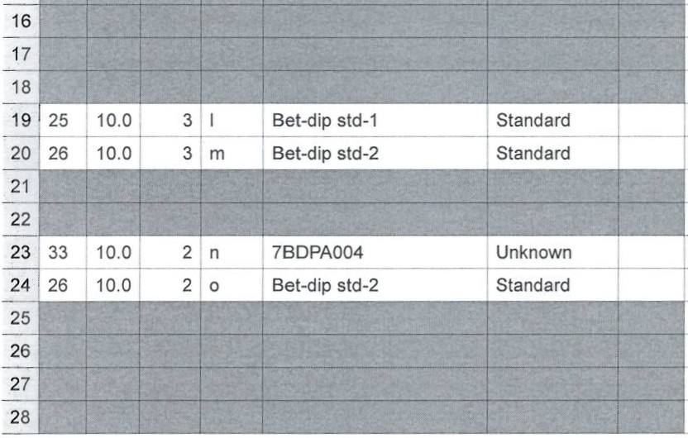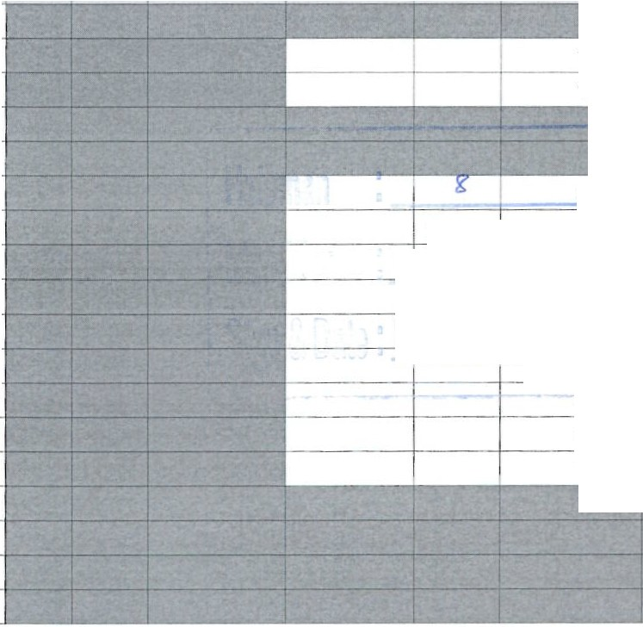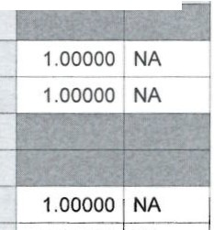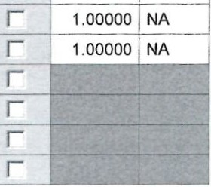

T

Processing

Bath Vessel Transfer Time RI Senstiivity Solvent SampleWeight Dilution Altered AUW_SG Ave_lD

2

3

Normal

Don't Process or Report Don't Process or Report Normal

Normal

Don't Process or Report Don't Process or Report Don't Proce ss or Report

1.0000

1.0000

r

1.0000 r

1.0000

r

r

6

7

8

r

2.0134 10.0000 r

r

**Q**

**C 170** 20

2.0112

10.0000

**01-0 8.05** 1 . 00 00

1.0000 r

1.00000 NA

1.00000 NA

-"-r

- -.

12 I

Don't Process or Report

Don't Process or Repo_rt Don't Process or Report

--r.oooo 1 .0 000 r 1.00000 NA

2.0071 10 .0000

2.0109 10.0000

1.0000 1.0000

r

1.00000 NA

1. Don't Process or Report
2. Don't Process or Report
3. Normal
4. Normal
5. Normal
6. Normal

|  |  |  |  |  |  |  |  |  |  |  |
| --- | --- | --- | --- | --- | --- | --- | --- | --- | --- | --- |
|  | | | | | | | | Clear Calibration | BDPA_Betoip Met Set |  |
| 2 | 25 | 10.0 | 3 | a | Bet-dip std-1  ---- | Standard  -<-- | | Inject Standards | BDPA_BetDip Met Set |
| 3 | 26 10.0 3 b Bet-dip std-2 Standard | | | | | | Inject Standards | | BDPA_BetDip Met Set |
| 4 |  |  |  |  |  |  | Calibrate | | BDPA_Betoip Met Set | a* b* |
| 5 |  |  |  |  |  |  | Clear Calibration | | BDPA_BetDip Met Set |  |
| 6 | 27 | 10.0 | 1 | C | 6BDPA002 st 9 top 1 | Unknown | Inject Samples | | BDPA_BetDipMet Set |  |
| 7 | 28 | 10.0 |  | d | 6BDPA002 st 9 top 2 | Unknown | Inject Samples | | BDPA_BetDip Met Set |  |
| 8 | 26 | 10.0 | 1 | e | Bet-dip std-2 | Standard | Inject Standards | | BDPA_BetDip Met Set |  |
| 9 | 29 | 10.0 |  |  | 6BDPA002 st 9 middle 1 | Unknown | Inject Samples | | BDPA_BetDip Met Set |  |
| 10 | 30 | 10.0 |  | g | 6BDPA002 st 9 middle 2 | Unknown | Inject Samples | | BDPA_BetDip Met Set |  |
| 11 | 26 | 10.0 |  | h | Bet-dip std-2 | Standard | Inject Standards | | BDPA_BetDip Met Set |  |
| 12 | 31 | 10.0 |  |  | 6BDPA002 st 9 bottom 1 | Unknown | Inject Samples | | BDPA_BetDip Met Set |  |
| 13 | 32 | 10.0 |  | i | 6BDPA002 st 9 bottom 2 | Unknown | Inject Samples | | BDPA_BetDip Met Set |  |
| 14 | 26 | 10.0 |  | k | Bet-dip std-2 | Standard | Inject Standards | | BDPA_BetDip Met Set |  |
| 15 |  |  |  |  |  |  | Calibrate | | BDPA_BetDip Met Set | b* e* h* k* |
| 16 |  |  |  |  |  |  | Quanlitate | | BDPA_BetDip Met Set | c* d * f' g* i* j* I |
| 17 |  |  |  |  |  |  | Summarize Custom Fields | |  |  |
| 18 |  |  |  |  |  |  | Clear Calibration | | BDPA_BetDip Met Set |  |
|  | | | | | | | Inject Standards | | BDPA_BetDip Met Set |  |
| Inject Standards | | BDPA_BetDip Met Set |  |
| Calibrate | | BDPA_BetDip Met Set | I* m* |
| Clear Calibration | | BDPA_BetDip Met Set |  |
| Inject Samples | | BDPA_BetDip Met Set |  |
| Inject Standards | | BDPA_BetDip Met Set |  |
| Calibrate | | BDPA_BetDip Met Set | **m* o\*** |
| Quantitate | | BDPA_BetDip Met Set | I n* |
| Summarize Custom Fields | |  |  |
| Condition Column | | FlusshingOff_60LC03 |  |

|  |  |  |  |  |
| --- | --- | --- | --- | --- |
| 9 | Don't Process or Report I | -- 2.0134 | 10.0000 | **r** 1.00000 NA |
| 10 |  | *'L* 2.0050 | 10.0000 | r 1.00000 NA |

- - - ---=6=B-D=PA002=-=St9:·...:•.n:.:-v=--i"n-'--P':...a::::n.d aan\2017_9 1\BDPA Bet.Dip_Tern late on EMPWPRD3 as aalfiani/GBL Chemist -Alter Sam Set

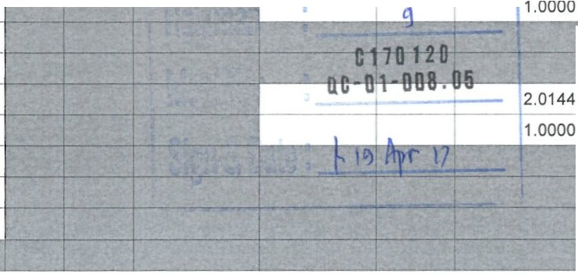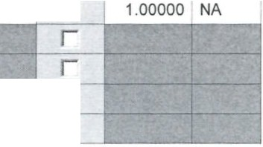

I I

Processing

Bath Vessel j Transfer Time RI Sensitivity Solvent SampleWeight Dilution Altered AUW_SG Ave_lD

19 Don't Process or Report 20

21

22

23

1. Don't Process or Report
2. Normal 26

27

28

1.0000

1.0000 r

1.0000 r

r

1.00000 NA

1.00000 NA

r

10.0000 I

1.0000 r

1.00000 NA

r

r

Don't Process or Report

Normal

Normal

Don't Process or Report

Normal

Normal

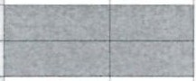

l Batch_lD ColumnNameC0 I Column_lD I Column_Temperature FlowRate Mobile_Phase No_of_Tabs Pre_No

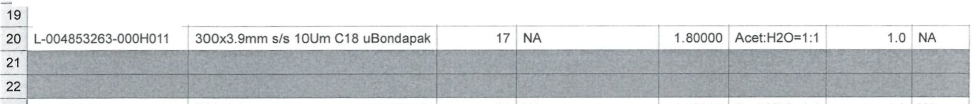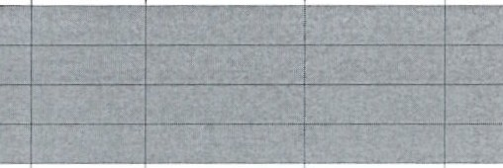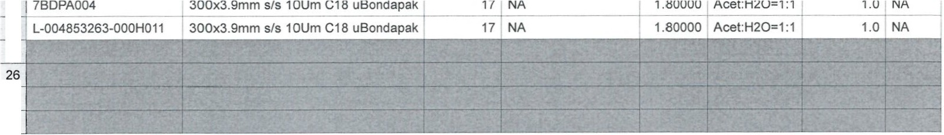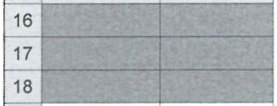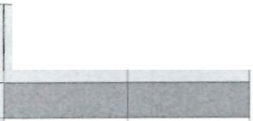

2 L-004853263-000H011

3 L-004853263-000H011

300x3.9mm si s 10Um C18 uBondapak 300x3.9mm si s 10Um C18 uBondapak

17 NA---

17 NA

1 .80000 Acet:H2O=1:1

1.80000 Acet:H2O=1:1

1.0 NA

1.0 **NA**

4 t--- - - - - - - - - - - - - - - - - - - - - - - - - - - - - - - - - 1--- - -+- - - - - 1--- - - -1 1

5

|  |  |  |  |  |  |  |  |  |
| --- | --- | --- | --- | --- | --- | --- | --- | --- |
| 6 | 6BDPA002 st 9 top 1 | 300x3.9mm s/s 10Um C18 uBondapak | 17 | **NA** | 1 .80000 | Acet:H2O=1:1 | 1.0 I | NA |
| 7 | 6BDPA002 st 9 top 2 | 300x3.9mm si s 10Um C18 uBondapak | 17 | **NA** | 1 .80000 | Acet:H2O=1:1 | 1.0 | **NA** |
| 8 | L-004853263-000H011 | 300x3.9mm s/s 10Um C18 uBondapak | 17 | **NA** | 1. 80000 | Acet:H20=1:1 | 1.0 | **NA** |
| 9 | 6BDPA002 st 9 middle 1 | 300x3.9mm s/s 10Um C18 uBondapak | 17 | NA | 1.80000 | Acet:H2O=1:1 | 1.0 | NA |
| 10 | 6BDPA002 st 9 middle 2 | 300x3.9mm s/s 10Um C18 uBondapak | 17 | **NA** | 1.80000 | Acet:H2O=1:1 | 1.0 | **NA** |
| 11 | L-004853263 -000H011 | 300x3 .9mm sis 10Um C18 uBondapak | 17 | **NA** | 1 .80000 | Acet:H2O=1:1 | 1.0 | **NA** |
| 12 | 6BDPA002 st 9 bottom 1 | 300x3.9mm si s 10Um C18 uBondapak | 17 | NA | 1.80000 | Acet:H2O=1:1 | 1.0 | **NA** |
| 13 | 6BDPA002 st 9 bottom 2 | 300x3.9mm s/s 10Um C18 uBondapak | 17 | **NA** | 1 .80000 | Acet:H2O=1:1 | 1.0 | NA |
| 14 | L-004853263-000H011 | 300x3.9mm s/s 10Um C18 uBondapak | 17 | **NA** | 1.80000 | Acet:H2O=1:1 | 1.0 | **NA** |
| 15 |  |  |  |  |  |  |  |  |
| 16 |  |  |  |  |  |  |  |  |
| 17 |  |  |  |  |  |  |  |  |
| 18 |  |  |  |  |  |  |  |  |
|  | L-004853263-000H011 | 300x3.9mm sis 10Um C18 uBondapak | 17 | NA | 1.80000 | Acet:H2O=1:1 | 1.0 | NA |



--

23 7BDPA004 300x3.9mm s/s 10Um C18 uBondapak 17 NA

t- - -

-1 - - -- -- - - - - -

24 j L-004853263-00H0011 300x3.9mm s/s 10Um C18 uBondapak 17 NA

25

27

28

Samp_Type Wavelength

# --

Samp_Type Wavelength

|  |  |  |
| --- | --- | --- |
|  | Samp_Type Wavelength | |
| 6 |  | 254.00000 |
| 7 | unknown | 254.00000 |
| 8  9 | standard | 254.00000 |
| unknown | 254.00000 |
|  | unknown | 254.00000 |

Samp_Type Waveel ngth

1. standard
2. standard

----,

254.00000

254.00000

unknown -

11Istandadr

1. unknown
2. unknown

254.00000

254.00000

254.00000

--t

14 standard 254.00000 19 standard

5 f-15----1,..--------- 20 standard

4

254.00000

254.00000 1

- - - - - 6"=-Bi' DPA002_St9inv in Pandaan\2017_O1\BDPABet.Dip_Template on EMPWPRD3 as aalfiani/GBL_Chemist - Alter Sample Set

21

22

Samp_TypeIWavelength

23 unknown 254.00000

24 standard 254.00000



25

26

27

28

*\0*

**C 17 0120**

**QC-01- 008.05**

